 | Do not manually edit this table.
Title | Plant Guidelines
Description | The purpose of this guideline is to provide practical advice on how to meet the requirements of the Occupational Health and Safety (Plant) Regulations 2007.
Author | Robyn McGaw
Organisation | La Trobe University

What is plant?

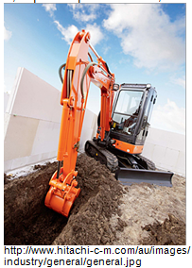
The purpose of this video is to provide practical guidance on how to meet the requirements of Occupational Health and Safety (Plant) Regulations 2007.

Plant: is machinery that processes material by way of a mechanical action which:
- Cuts, drills, punches or grinds
- Presses, forms, hammers, joins, or moulds material
- Combines, mixes, sort, packages, assembles, knits or weaves material

Plant also includes lifts, cranes, tractors, earth moving equipment, pressure equipment, hoists, powered mobile plant, plant that lifts or moves people or materials, amusement structures, high powered lasers, turbines, explosive powered tools, scaffolds, temporary access equipment.

(Commonwealth of Australia – Copyright Act 1968 Warning
This material has been copied and communicated to you by or on behalf of La Trobe University under Part VB of the Copyright Act 1968. Do not remove this notice.)

What are potential hazards with plant?

Hazard means the potential to cause injury or illness. Examples of potential harm that plant or associated systems of work may cause to people at work include:
- Injury from entanglement
- Crushing by falling or moving objects, or plant tipping over
- Crushing from people being thrown off or under plant
- Cutting or piercing due to sharp or flying objects
- Friction burns
- Injury from high pressure fluids, electricity and/or explosion
- Slips, trips and falls

Systems of work and safe operating practice
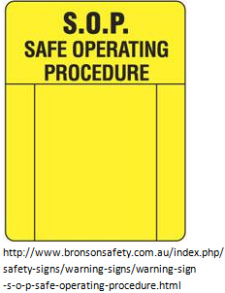
Systems of work describe a wide range of activities, which can contribute to safe work. These may include - policies and procedures, systems of communication, organisation of work, skills and experience, work practices, emergency procedures.

Safe operating practices are developed during the risk assessment to alert employees and operators of the hazards associated with the plant. Safe operating practices do not take the place of training or operation manuals. They should be signed off by management, dated and easily accessible.

Plant exemptions and notification of design and registration
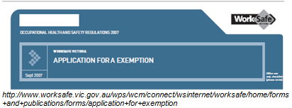
Plant which relies exclusively on manual power for its operation or which is designed to be primarily supported by hand is not covered by these regulations. General duties of care as required under the Occupational Health and Safety Act still applies.

OHS Regulations require notification of plant designed after July 1995. Ref OHS Regulations Part 1 Schedule located on the Appendix on this web page.

Plant requiring registration of design

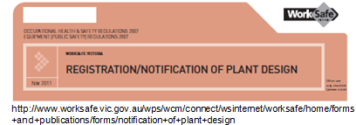
Plant requiring registration of design includes:
- Boilers level A, B or C pressure equipment
- Definitions of boiler hazards:
  - Hazard level A (high hazard) - applies to large vessels e.g. 4000 tonne ethane vessels, 7000 tonne butane or propane
  - Hazard level B (medium hazard) – applies to most shop fabricated boilers and pressure vessels
  - Hazard levels C and D (low and extra low hazards respectively) – apply to small pressure equipment or equipment with low hazard content
- Tower cranes and self-erecting tower cranes
- Lifts
- Building maintenance units, workboxes, prefabricated scaffolding, vehicle hoists, mobile cranes with a safe working load greater than 10 tonnes
- Hoists with a platform movement in excess of 2.4 metres designed to lift people, boom-type elevated work platforms; gantry cranes with safe working load of 5 tonnes
- Amusement structures

Responsibilities

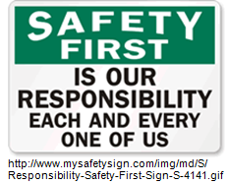
Deans, Heads of Schools and Divisional Managers are responsible for ensuring that:
- All plant owned or operated by the University is assessed in accordance with the Regulations and any health and safety risks identified are eliminated or controlled
- All new purchases and plant acquisitions are assessed in accordance with the Regulations by the supplier, manufacturer and/or designer
- All plant designed, modified and/or manufactured by University personnel, including contractors are assessed in accordance with the Regulations
- Notification and registration of certain plant designs and items of plant as required by the Regulations is arranged
- Information, instruction and training are provided to all staff exposed to risks associated with plant
- Records are maintained of all risk assessments
- Licences are obtained

Prior to purchasing plant and equipment

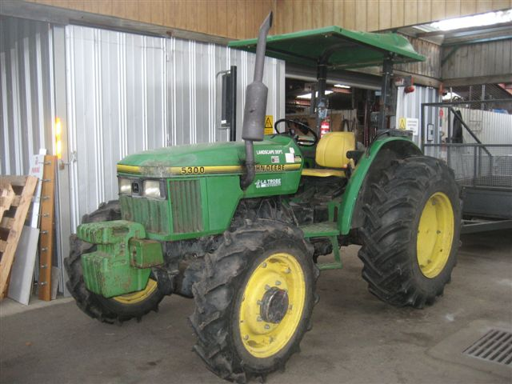
All risks associated with the use of the intended plant/equipment and processes must be considered. Elimination, substitution or engineering controls should be applied at the planning, design and purchasing stages. Suppliers have a duty to provide information on hazards associated with use of plant and equipment.

All hazards associated with the installation, commissioning, erection and use of plant and systems of work associated with that plant are to be identified:
- Before the plant is used for the first time
- Before any alterations to the plant or change in the way the plant is used or a system of work associated with the plant, including a change in the location of the plant
- Before the plant is used for any other purpose than for which it was designed
- If new or additional information about hazards relating to the plant or its associated systems of work becomes available to the employer
- For all plant in the workplace at the date of the Regulations

Plant and equipment hazards may include:
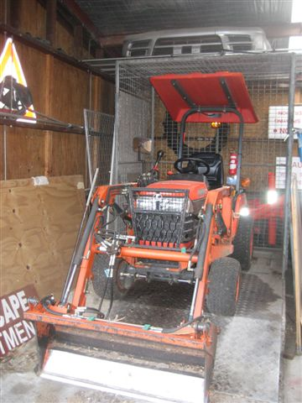
- Injury from entanglement
- Crushing by falling or moving objects, or plant tipping over

Crushing from people being thrown off or under plant
- Cutting or piercing due to sharp or flying objects
- Friction burns
- Injury from high-pressure fluids, electricity and or explosion
- Slips trips and falls

Suffocation
- Ergonomic requirements
- High temperatures
- Dust, vibration, noise, radiation

Installation, erection and commissioning of plant
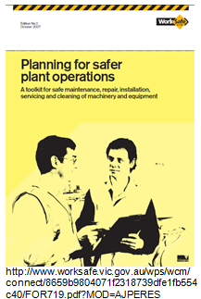

All plant installed or erected must:
- Provide sufficient clear working area around the plant
- Ensure the layout of plant does not affect access and egress to and from the workplace
- Not be brought into operation unless the commissioning process is established

Guarding of plant

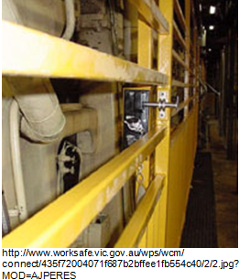
If plant contains moving parts and parts may break or be ejected, guarding must be installed to control any risk of parts being ejected.

Guarding installed to control risk of injury must be designed for the purpose to prevent access to any danger points. Permanent or fixed guarding is required when access to plant is not required during operation, maintenance, cleaning.

If access is required during operation, then an interlock physical barrier may be installed that allows access to the area being guarded does not present a risk. Where it is not practicable to use guarding, a physical barrier that can only be altered or removed by use of tools may be used. If the above is not reasonably practicable, a presence sensory safety guard system may be considered. At no time must the guarding be able to be by passed or disabled.
Any pipe work associated with plant is required to be adequately insulated or guarded.

Operator controls must be!

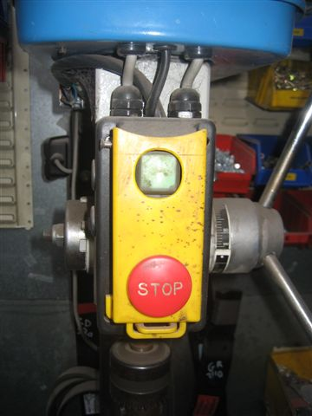
- Suitably identified
- Readily, conveniently located by each person using the plant
- Located or guarded to prevent unintentional activation
- Able to be locked into the “off” position
- Where more than one stop control is fitted, multiple stop controls are of the “stop or lock off“ type to ensure plant cannot be restarted
- Emergency stop devices must be prominent, clearly and durably maintained and accessible to each operator, coloured red and cannot be adversely affected by electrical or electronic circuit malfunction
- Emergency warning devices if fitted to be positioned to work effectively

Powered plant

Where powered mobile plant is to be used, consideration must be given to traffic management plans.
Consideration should be given to separation of pedestrian from vehicle access to ensure visibility, space and safety. Pedestrian access should be organised in such a way that there will be no perceived or real benefit in taking shortcuts through vehicle access ways. There should be no risk of powered plant colliding with pedestrians or other powered plant. Warning devices are to be fitted to powered plant where there is a possibility of colliding with a pedestrian.

Persons other than the operator are not to ride on the powered plant unless that person has the same protection as the operator.

Tractors must have rollover protection unless there is no likelihood of overturning or the tractor weighs less than 560Kg (without fuel, water, lubricants).

Keys must not be left in unattended power plant.
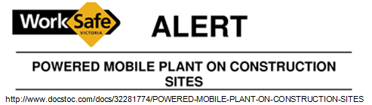

Electrical plant
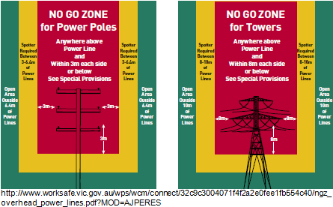
Plant must not be used if conditions give rise to a risk due to the presence of electricity. When maintenance, cleaning or repair of electrically powered plant is being carried out, the plant must be disconnected from the electricity supply.

Excavations using plant near underground power lines must ensure that there is no risk to the operators.

Plant operated near overhead electrical power lines must ensure that there is no risk to the operators.

All electrical plant and equipment must be test tagged prior to use.

Plant used to lift or suspend loads including people & materials

Plant must be specifically designed to lift or suspend the load.
Loads must not be suspended or pass over a person.
The load must be in control during the activity
As far as practicable no load should be lifted simultaneously by more that one piece of equipment.

Where plant is to be used to lift persons:
- The people are lifted or suspended in a work box which is securely attached to the plant
- The people remain in the work box while they are being lifted or suspended
- A safety harness must be provided and worn by the person, if there is likelihood of a person falling from a height
- There must be means of egress from the plant in the event of a failure in the normal operation of the plant

Lifts
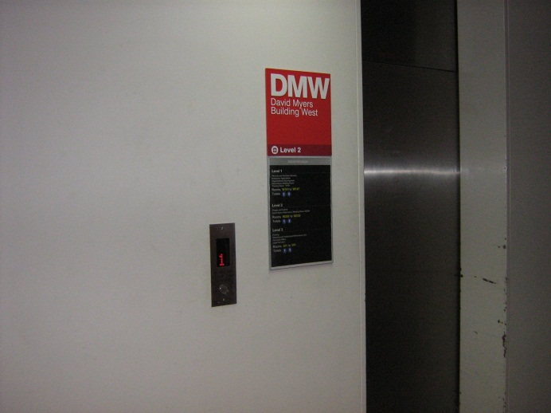
All lifts, registration details and their records are maintained by the Infrastructure and Operations Division of the University.

Industrial lift trucks

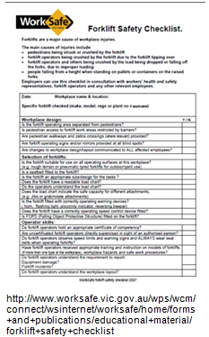
The operator of a fork lift truck must have a current licence to operate, noting that a licence expires after five years. Only licenced operators or operators under direct supervision (within sight and sound) are able to operate a forklift. Seat belts are required to be worn when operating a forklift.

Keys must not be left in unattended plant.

Lift trucks must be equipped with the appropriate lifting attachments for the load and used in a manner that ensures the operator is not at risk.

Forklifts must be assessed to ensure that the likelihood of powered plant overturning or of a falling object coming into contact with the operator or the operator being ejected from the plant is eliminated.

Passengers on forklifts is prohibited unless a seat is provided, has seat restraints and where the seat is located within the protection zone. No person must ride on the powered mobile plant unless the person is afforded a level of protection from exposure to risk, which is equivalent to that provided by the operator.

Preoperative checks are required before daily operation. The WorkSafe Forklift Checklist should be recorded and maintained. Refer to the Appendix on the web page for the checklist.

A certificate of competency is not required to operate a pedestrian operated fork-lift truck, but there is a responsibility on managers to provide information, instruction, training and supervision to employees as are necessary to enable them to perform their work in a manner that is safe and without risks to health. Where a pedestrian operated forklift is available, only trained staff should be authorised to operate this equipment. Daily operational checks should be undertaken and records maintained by managers.

Damaged, alteration and dismantling plant
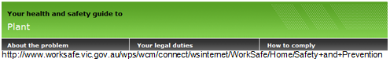
Where the employer is assessing the function and condition of plant that is impaired or damaged and presents an immediate risk to health and safety, the plant should be withdrawn from use until the risk is controlled. Lockout procedures must be implemented.

Where modification is made to the plant, or where the plant is to be altered, the employer should ensure that the design of the alteration has undergone a hazard identification and risk assessment. When the plant is altered, it should be inspected and tested having regard to the design specifications for the alteration. This should occur before the plant is returned to service.

Where plant is to be dismantled, decommissioned or otherwise sold or disposed of, the employer should ensure that any relevant information provided by the designer and manufacturer is given to the person who is to dismantle or take control of the plant.

Registration of plant
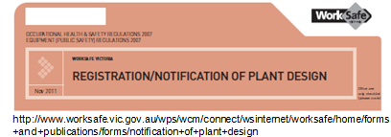
Certain items of plant cannot be used in the workplace unless registered with WorkSafe Victoria.
These include:
- Boilers categorised as Hazard A,B,C according to the criteria identified in AS3920-part 1
- Pressure vessels categorised as Hazard level A,B or C in AS 3920 part 1 other than gas cylinders which AS2030, or LPG fuel vessels which AS3509 applies
- Tower cranes
- Lifts
- Building maintenance units
- Amusement structures
- Concrete placing units(truck mounted with boom)
- Mobile cranes with safe working load greater than 10 tonnes

Licences

Anyone who operates or uses high-risk items of plant must have a licence. Employers must ensure that their employees have the proper licences for the plant they operate or use. The expiry date for licences is 5 years. A licence holder must keep evidence of their licence available for inspection. Alternatively, employees can work under the direct supervision of someone with the relevant licence, to gain the necessary training.

Licences are required for:
- Scaffolding (basic, intermediate, advanced), dogging and rigging (basic, intermediate, advanced)
- Crane, hoist and forklift operation
- Pressure equipment operation.
Refer to Schedule 3 of Regulations for full list of licence requirements, located in the Appendix section on this web page.

Information, instruction and training

When plant is not in use it must be left in a state which does not create a risk (so far as is practicable) for any person.

Training, information and instruction are to be provided to employees to ensure that the work can be performed in a manner that is safe and without risks to health.

Risk assessment and control

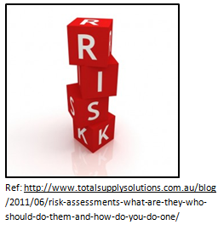
Risk assessment is the process of determining whether there is a risk associated with each of the hazards identified, that is, whether there is any likelihood of injury or illness.

Risk control
Risk control is the process of implementing measures to reduce the risk associated with a hazard. When controlling risk, the hierarchy of control should be considered in order of priority.

Hierarchy of control
The hierarchy of control is the established priority order for the types of measures to be used to control risks.
- Elimination of the hazard
- Substitution e.g. of the equipment or substance
- Engineering controls, controls, which use engineering measures to change the physical characteristic of plant to eliminate or reduce risk, e.g. guarding
- Administrative controls, controls, which use systems of work to eliminate or reduce, risk e.g. supervision, training, and rotation
- Personal protective equipment (PPE)

Plant identification, assessment and control, Step 1 Consultation

OHS Regulations place an obligation on the employer to consult with a health and safety representative of a designated work group. In particular, consultation with the relevant health and safety representative must occur where the hazard identification, risk assessment or control of risks processes affects the health and safety representative’s work group.

Consultation should take place as early as possible when planning for the introduction of new or modified plant or systems of work associated with the use of plant, to allow for possible changes arising from the consultation to be incorporated.

Consultation mechanisms may include - direct discussions, department meetings, health and safety committee meetings, hazard reports, or inspections.

Consultation between employers and persons involved in the supply of plant may contribute to the elimination or reduction of risks associated with plant. Employers should use the regular contact with their suppliers to discuss relevant health and safety issues associated with plant.

Steps 2, 3, 4 and 5

Step 2 Identify all plant in the Department/School
Document all hazards on the Plant Compliance Form (available on the OHS web site.)

Step 3 Risk Assessment

Once hazards associated with plant have been identified, using the Plant Hazard Identification Checklist, each identified risk must be assessed to determine whether the risk is a high, medium or low priority.
Refer to the La Trobe University Risk Control Procedure.

Step 4 Risk Control

The primary duty of the employer in relation to risk control is to eliminate where practicable, any risk associated with plant and associated systems of work.

Controls must be implemented as far as practicable using the hierarchy of control. (Refer to the Risk Assessment and Control section in this video for additional information.)

Step 5 Safe operating practices

Safe operating practices are to be developed and displayed on or near plant to alert employees and operators to the hazards associated to the plant. Examples of forms are available on the OHS web site.

Step 6 Evaluation of plant in use

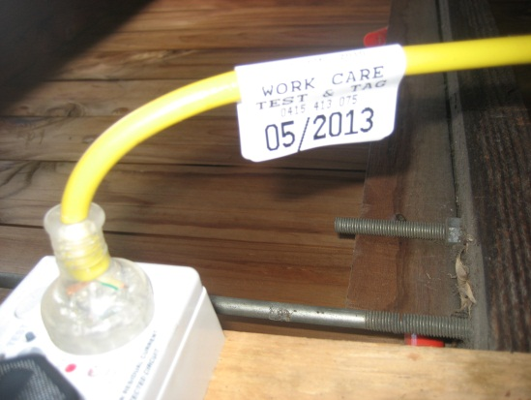
Where plant is currently in use, employers are required to carry out inspections to monitor risks to health and safety. Where safety features or warning signs are incorporated into the plant, they must be used as intended, maintained and tested.

Plant should be maintained, cleaned and inspected in accordance to the recommendations of the designer and manufacturer.

Systems of work should be provided and maintained for employees, maintaining, inspecting or cleaning plant so as to eliminate risks to health and safety. Where practicable, the systems of work should involve stopping the plant before maintenance, cleaning or repairs are commenced and the use of lockout or isolation devices and permit to work systems.

This guideline contains information of a general nature. For specific advice, contact La Trobe Health and Safety on 9479 2462.

First issued and endorsed by Executive OHS Committee March 2010. Revised as a guideline April 2010. Authorised by Manager La Trobe Health and Safety,Risk Management

