 | Do not manually edit this table.
Title | First Aid Online Training
Description | First aid information for managers and first aiders.
Author | Robyn McGaw
Organisation | La Trobe University

First Aid Overview

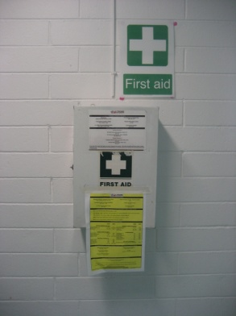
First aid is the initial treatment of people suffering an injury or illness and begins at the scene of the injury/illness. First aid officers are not responsible for ongoing treatment. Designated first aiders are protected under La Trobe University insurance policies when treatment given falls within the scope and competence of a first aider’s training, and is not a deliberate or wilful act with the intent to cause personal injury or harm.

Under the Occupational Health and Safety Act Section 21(2)(d) and 21(1), workplaces are required to provide first aid facilities.

What does a first aid officer do?

- Provides initial first aid care to their level of training.
- Records details of first aid treatment given. This form should be maintained on file for seven years within departments.
- Arranges referral as required to medical assistance i.e. ambulance, local medical centre.
- Maintains first aid equipment / kits and ensuring that a record is kept (dated) when the first aid box is checked. For field trip kits - generally 6 monthly or prior to field trips.

(Commonwealth of Australia – Copyright Act 1968 Warning
This material has been copied and communicated to you by or on behalf of La Trobe University under Part VB of the Copyright Act 1968. Do not remove this notice.)

Responsibilities for Provision of First Aid

Area managers are required to:
- Ensure a first aid assessment as per the First Aid Compliance Code 2007 is undertaken and documented. Refer to attachment on the web page.
- Appoint and train designated first aiders. There must be sufficient first aid personnel for all areas with consideration given to after hours and field trip requirements. Schools/Areas are responsible for the cost of training.
- Ensure first aid kits are provided and regularly maintained.
- Provide employees with practical instructions in the nature of first aid facilities, the locating of first aid kits, the names and work locations of trained first aiders and the procedures to be followed when first aid is required.
- Maintain a register of first aid officers, containing name, location, department, training expiry and CPR expiry dates. Forward copies/updates to ohs@latrobe.edu.au.
- Maintain a register of location of first aid kits.
- Maintain a list of location of defibrillators.

Training Required

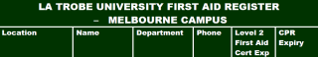
First aid officers are required to hold a current certification in first aid obtained through an approved provider equivalent to a “First Aid in the Workplace” (level 2). Certification is for three years and includes an annual update in cardio pulmonary resuscitation.

A register of training is to be maintained by area managers/ health and safety consultative committees and will contain name, certificate date and annual Cardio Pulmonary Resuscitation (CPR) refresher date along with details of the training provider. On completion of training first aid officers are asked to provide these details to their area managers. For crisis management purposes La Trobe Health & Safety will maintain a central register of first aiders including training details. Please ensure updated training details are forwarded to ohs@latrobe.edu.au.

Field trips to remote areas may require specific first aid training.

How to Establish First Aid Compliance

First aid assessments must be undertaken in each School/ Division to determine the appropriate first aid facilities and number of suitably trained people. The assessment should be documented and reviewed periodically in consultation with the first aider and the Health & Safety Representative with consideration to:
- Size and layout of the workplace
- The number and distribution of employees including arrangements such as shift work, after hours and field trips
- The nature of hazards and the severity of the risk
- The location of the workplace
- Known occurrences of accidents or illness.

Assistance with this process can be organised through La Trobe Health & Safety.

Office, library and retail areas are generally classed as low risk areas. The number of first aid officers required in low risk areas is one first aid officer for 10/50 staff, two first aid officers for 51/100 staff and an additional first aid officer for every 100 staff.

Higher risk areas such as plant rooms, maintenance areas and laboratories require one first aid officer for 25 staff, two for 26/50 staff and an additional first aid officer for every 50 staff. Please note adjoining areas may share a first aid officer.
All University security staff members are required to be trained in first aid.

Employee Awareness
The names of first aid officer, their contact numbers, location of first aid kits and procedures to be followed in a medical emergency should be displayed in each area in a central location. At commencement, all new employees are to be informed during orientation of the name of their area first aid officer is and how the first aid officer can be contacted. All employees are to be made aware of any changes to first aid processes.

First Aid Officers
The number and competencies of first aid officers will vary between workplaces depending on assessment factors. It is desirable that first aiders be selected from those staff members whose duties normally do not take them away from the workplace.

Prospective first aiders should be:
- Staff who show evidence of enthusiasm and a capacity to deal with injury and illness
- Able to relate well to other staff
- In reasonable health
- Able to exercise sound judgement especially in relation to the need to involve other support services
- Able to be called away from their ordinary work at short notice
- Appointed to this role of their own free will.

First Aid Kit
First aid kits are generally located in staff areas. They should be sturdy, protected from dust and damage, not locked, signed (with white cross /green background) and prominently displayed. Medications such as Panadol or antiseptic creams must not be stored in the first aid box.

Location and quantity
In low-risk workplaces, compliance is achieved by providing:
- One first aid kit for 10 to 50 employees
- One additional kit for every additional 50 employees up to 200
- One additional kit for every 100 additional employees above 200.

In higher-risk workplaces, compliance is achieved by providing:
- One first aid kit, including specific first aid kit modules, for up to 25 employees
- Two kits, including specific first aid kit modules, for up to 50 employees
- One additional kit, including specific first aid kit modules, for every additional 50 employees.

Where an employee or group of employees does not have timely access to appropriate medical and ambulance services, compliance is achieved by providing at least one kit for every 25 employees. For isolated, remote locations or mobile workplaces, employees need to have access to appropriate first aid kits.

Where there are separate work areas, it may be appropriate to locate first aid facilities centrally and provide portable first aid kits in each work area. This may include motor vehicles.

Basic Contents
The basic contents of the first aid kit should include:
- LTU Emergency phone numbers “specific to your campus”, phone numbers, hours of opening and directions to the local medical clinic
- Basic first aid notes
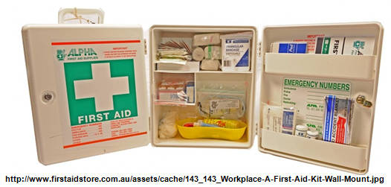
- First aid record of treatment form
- Pen
- Resuscitation masks
- Individual sterile adhesive dressings
- Sterile eye pads
- Safety pins
- Selection of wound coverings
- Bandages
- Triangular bandages
- Disposable gloves
- Adhesive tape.
Note: some items may have expiry dates.
Additional kit modules for burns or eyes may be required, where hazards are identified. These kit modules should be included where there is a possibility of a person sustaining a serious burn. Such places may include:
- Places where heat is used in the process
- Flammable liquids are used
- Chemical acids or alkaline are used
- Other corrosive chemicals are used.
Where highly toxic or corrosive chemicals are stored additional first aid facilities need to be provided if specified in material safety data sheets. These may include emergency showers, eye wash stations and where applicable the provision of poison antidotes.

Eye kit modules do not replace the need for eye wash facilities.

Field Trips

All vehicles and caravans used on field trips, (excluding those to other workplaces) must travel with a standard first aid kit.

Where people will be working in remote locations away from medical assistance an assessment of the likely hazards that may occur must be reviewed and appropriate equipment taken.
The following items should be considered for inclusion in field trip first aid kits:
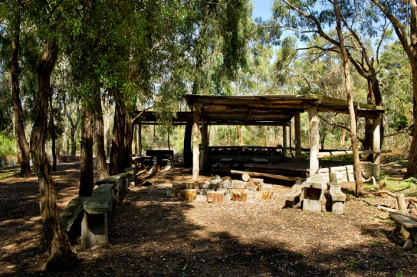
- Emergency reference manual
- Broad crepe bandages (for snake bites)
- Cervical collar (for spinal / neck injuries)
- Large clean sheeting (for covering burns)
- Thermal blanket (for treatment of shock)
- Basic splints
- Single use cold packs
- Eye wash
- Analgesics. (First aid officers must be trained on the use)
- Communication link, i.e. Whistle (for attracting attention), phone, V sheet (orange with a large V on one side used as a distress signal), EPERB (Electronic Positioning Radio Beacon) distress signal
- Torch / flashlight.

All first aid officers going on field trips must have appropriate training in the usage of the specific equipment. The field first aid officer is responsible for reviewing the field trip kit prior to each field trip.

Restocking of First Aid Kits

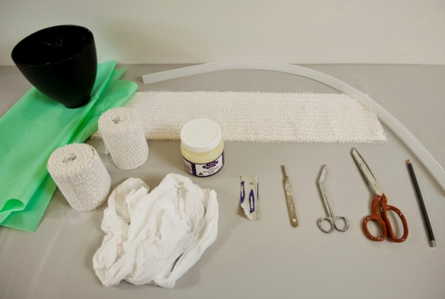
Restock your kit as part of regular safety inspections by contacting La Trobe’s preferred supplier OfficeMax on 136629 who can supply all of the above items. Alternatively you can arrange an external first aid provider to restock your kits (at School or Faculty’s cost). Pl
All deficiencies in the first aid kit must be reported to the area manager.

Recording Reporting and Confidentiality

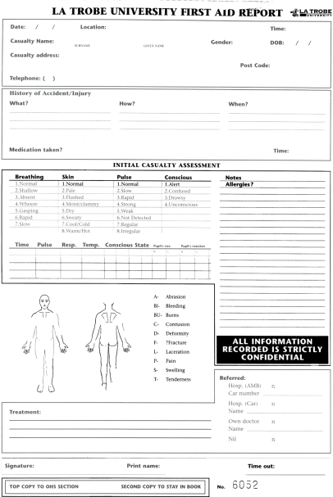
University first aid officers are required to record all first aid treatments on the First Aid record. Records are to be maintained within the department. A supply of these forms is to be kept with the first aid kit.

If first aid officers have been advised that persons in their workplace have medical conditions they are required to treat such information in the utmost confidence. Such information may only be revealed to the appropriate personnel, should a medical emergency occur.

Infection Control Guidelines

To minimise the transmission of infection first aid officers are required to follow infection control measures through the wearing of disposable gloves, hand washing and appropriate disposal of medical waste.
Incidents involving blood or body fluid spills should be reported and attended to by appropriate trained cleaning staff.

General Principles:
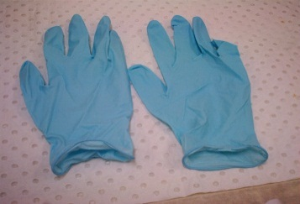
- Collect cleaning materials and equipment
- Wear disposable cleaning gloves
- Eyewear and plastic apron should be worn where there is a risk of splashing occurring
- Wipe up spot immediately with paper towel
- Place contaminated absorbent material into impervious container or yellow infectious waste bin
- Disinfect area (bleach solution)
- Wash hands
- Clean eyewear if used.

All medical waste must be disposed of as per University procedures.

Immunisation Cover

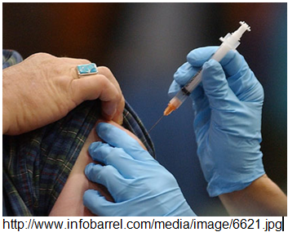
It is recommended that first aid officers are immunised for Hepatitis B if they are likely to have contact with blood or bodily fluids. These should be arranged through your supervisor and will be charged to the employing department. Immunisation records are to be maintained by area managers. Please inform La Trobe Health & Safety at ohs@latrobe.edu.au of immunisations.

Chemicals and MSDS
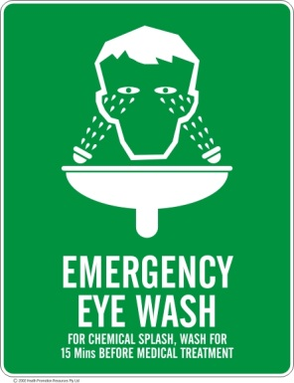
If chemicals are used in your area the first aid officer should be made aware of the location of the Material Safety Data Sheets (MSDS) for each chemical. MSDS provide information on first aid treatment where there is an exposure to a chemical. MSDS are usually stored in orange folders within each department.

MSDS only have a shelf life of 5 years.

Defibrillator

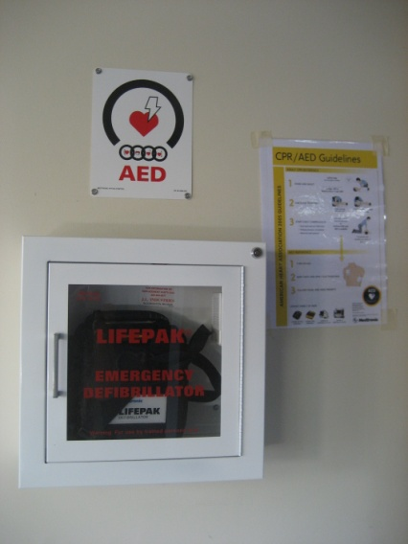
Defibrillators are located at all University campuses, detailed as follows. Please notify La Trobe Health & Safety (ohs@latrobe.edu.au or (03) 9479 2462) if these units have been tampered with or the low battery indicator light shows.

An orientation checklist is available as an appendix to this document and is available on the First Aid web page.

Training on defibrillators is provided to all first aid officers as part of the first aid certification.

Campus | Location | Units
Melbourne | Sports Centre- reception | 1
 | Agora Theatre – alarmed cabinet in food court | 1
 | Library – information desk | 1
 | Union Building- alarmed cabinet walkway level 1 | 1
 | WLT- alarmed cabinet in foyer | 1
 | Security- security cars and central control-cabinet | 3
 | Psychology (Faculty Owned) | 1
 | Health Science Clinic (Faculty Owned) | 1
Bendigo | Doctors rooms | 1
 | Student centre- foyer | 1
Albury- Wodonga | Library – level 1 | 1
 | Theatre - foyer | 1
Shepparton | Office area | 1
City Campus | Office area | 1
Mildura | Theatre foyer | 1

Transport Arrangements for an Injured Person

Emergency Situations:
An ambulance should be called for all serious injury / illness or stretcher type cases, e.g. chest pain, fall from height, or head injury etc.

When an ambulance is required contact your campus emergency number for assistance. This is to ensure security is aware of the emergency, able to provide back-up first aid assistance and able to direct the ambulance to the site of the incident.

First aid officers are asked to call 000 to provide details of the injured person directly to the ambulance staff.
Be prepared when calling for an ambulance you will be required to give your name, your exact location, your contact phone number, what the medical emergency is. If possible have someone on “look out for the ambulance”.

All ambulance cases will be taken to a public hospital and patients are responsible for accounts.

Please note:
The La Trobe University Medical Centre, located at the Melbourne campus does not have an emergency service.

All holders of Victorian Health Care cards and Pensioner Concession cards are entitled to free ambulance and air ambulance travel anywhere in Australia. This covers all emergency transport treatment and non-emergency transport on the recommendation of a doctor and approval by Ambulance Victoria. Dependants listed on these cards are also covered.

Non-Emergency Situations – Non-Life Threatening

Always recommend that a patient seek further medical treatment, preferably through the patient’s own doctor, otherwise through a local medical centre or emergency department.

If referring a patient to a medical centre it is recommended that you contact the medical centre prior to sending a patient. An injured person should be accompanied to a medical centre (by a first aid officer if possible) and “handed over” to medical staff. Security may be able to assist in providing transport (Melbourne Campus) or use department cab charges. First aid officers are not responsible for any payments.

If an employee is injured at work and the injury is work related a claim for workers compensation should be made by the patient. Further information is available from La Trobe Health & Safety (ohs@latrobe.edu.au or (03) 9479 2462).

Local Medical Centres

Melbourne Campus
La Trobe Medical Centre  Cnr Plenty Rd and Kingsbury Drive, Bundoora. Phone 9473 8885 | Summerhill Medical Centre  830 Plenty Road, Reservoir (past Target / Safeway). Phone 9471 3788
Austin Hospital  145 Studley Road, Heidelburg. Phone 9496 5000 | Northern Hospital  185 Cooper St, Epping. Phone 8405 8000

Bendigo
Bendigo Hospital, 62 Lucan Street, Bendigo. Phone (03) 5454 6000

Albury/Wodonga
Albury-Wodonga Health, Wodonga Campus, Accident Emergency, Vermont Street, Wodonga. Phone (02) 60517350

Transport to Medical Centre Non-Urgent Cases

Students: Suggest a family member or friend accompanies the injured to medical assistance.

Staff: A family member or friend may be able to assist to get someone to the local medical centres.
Cab charges may be required.

Other campuses and research centres:

Emergency situations: Refer to campus emergency numbers (Emergency Information, La Trobe University).

Non-emergency situations: Refer to your local medical centres/emergency departments.

